**Project 2– 1-digit BCD Display**

Sketch simulates a 1-digit BCD display, where the high order bit appears at the top and the low order bit is on the bottom.

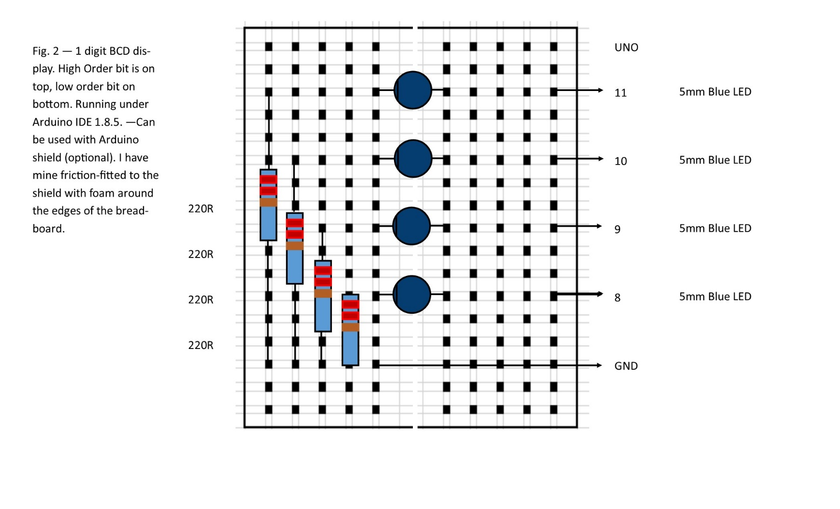

Code for 1-digit BCD Display sketch

// 1-digit BCD Counter - by Bill Jenkins 07-17-2018

// This sketch simulates a one digit BCD counter

// with the clock time set by parameter

// define variables for BCD output, d = high order bit, a = low order bit

int BCDd = 11; // high order bit

int BCDc = 10;

int BCDb = 9;

int BCDa = 8; // low order bit

int CYCLE = 1000; // delay time in milliseconds

int i = 0; // test for start

void setup() { // initialize output pins

pinMode(BCDd, OUTPUT);

pinMode(BCDc, OUTPUT);

pinMode(BCDb, OUTPUT);

pinMode(BCDa, OUTPUT);

}

void loop() {

//light all four LEDs to indicate sequence start

if (i==0){

digitalWrite(BCDd, HIGH);

digitalWrite(BCDc, HIGH);

digitalWrite(BCDb, HIGH);

digitalWrite(BCDa, HIGH);

delay(CYCLE);

i++;

}

// write a BCD '0'

digitalWrite(BCDd, LOW);

digitalWrite(BCDc, LOW);

digitalWrite(BCDb, LOW);

digitalWrite(BCDa, LOW);

delay(CYCLE);

// write a BCD '1'

digitalWrite(BCDd, LOW);

digitalWrite(BCDc, LOW);

digitalWrite(BCDb, LOW);

digitalWrite(BCDa, HIGH);

delay(CYCLE);

// write a BCD '2'

digitalWrite(BCDd, LOW);

digitalWrite(BCDc, LOW);

digitalWrite(BCDb, HIGH);

digitalWrite(BCDa, LOW);

delay(CYCLE);

// write a BCD '3'

digitalWrite(BCDd, LOW);

digitalWrite(BCDc, LOW);

digitalWrite(BCDb, HIGH);

digitalWrite(BCDa, HIGH);

delay(CYCLE);

// write a BCD '4'

digitalWrite(BCDd, LOW);

digitalWrite(BCDc, HIGH);

digitalWrite(BCDb, LOW);

digitalWrite(BCDa, LOW);

delay(CYCLE);

// write a BCD '5'

digitalWrite(BCDd, LOW);

digitalWrite(BCDc, HIGH);

digitalWrite(BCDb, LOW);

digitalWrite(BCDa, HIGH);

delay(CYCLE);

// write a BCD '6'

digitalWrite(BCDd, LOW);

digitalWrite(BCDc, HIGH);

digitalWrite(BCDb, HIGH);

digitalWrite(BCDa, LOW);

delay(CYCLE);

// write a BCD '7'

digitalWrite(BCDd, LOW);

digitalWrite(BCDc, HIGH);

digitalWrite(BCDb, HIGH);

digitalWrite(BCDa, HIGH);

delay(CYCLE);

// write a BCD '8'

digitalWrite(BCDd, HIGH);

digitalWrite(BCDc, LOW);

digitalWrite(BCDb, LOW);

digitalWrite(BCDa, LOW);

delay(CYCLE);

// write a BCD '9'

digitalWrite(BCDd, HIGH);

digitalWrite(BCDc, LOW);

digitalWrite(BCDb, LOW);

digitalWrite(BCDa, HIGH);

delay(CYCLE);

}